Mini Course: LMS Selection Assignment Instructions
Overview
Educators must develop a learning environment that reflects how people learn in today’s world (Veletsianos, 2016). Student satisfaction and whether distance learning techniques can provide equivalent learning as face-to-face instruction are two main areas of concern when implementing distance learning (Moore & Diehl, 2018). It is important to understand distance education varies in effectiveness just as traditional face-to-face learning (Moore & Diehl, 2018). Creating an organized, cohesive online course is extremely important (Nilson & Goodson, 2018). When creating a mini course such as this one it is important to make sure all your course elements align (Nilson & Goodson, 2018). Nilson & Goodson (2018) state that if you can take any activity in your course (assignment, assessment, discussion etc.…) and align it with your course objectives you improve learning as much as fourfold.

Instructions
For this assignment you write a 2-4-page paper in APA format where you choose an audience, topic, course objectives, and appropriate LMS for your mini-course you will create. You will want to consider the key principles Nilson & Goodson (2018) discuss in Chapter 3 and refer to the Understanding by Design resource provided in Module 2 as you establish your topic and objectives for your mini course. You need to use the ISTE Educator Designer Standards (5) as a guide while you create this course.

The learner audience for your project will fall into one of the three categories:

  - K12 or Higher Ed. students. In Option 1, you will build your mini-course using content that already exists from a unit you have taught on a critical topic. The mini-course you create will be used as part of a blended/flipped classroom approach.
  - Adult learners from your work setting. In Option 2 you are choosing a topic that you can use for training purposes at your current work setting.
  - Adult learners in the general population. If neither of the above two scenarios fit your current setting you may use a simulated audience.

Identify Topic and Course Objectives:

- You will want to identify a topic for your mini course and provide 3-5 course objectives.
- You will want to refer to the Understanding by Design (UbD) website provided in Module 2 and Chapter 2 from Nilson & Goodson (2018) as you establish your topic and objectives for your mini course.
- After you have clicked on the UbD website from Module 2, you will need to click the following link to view the PDF:
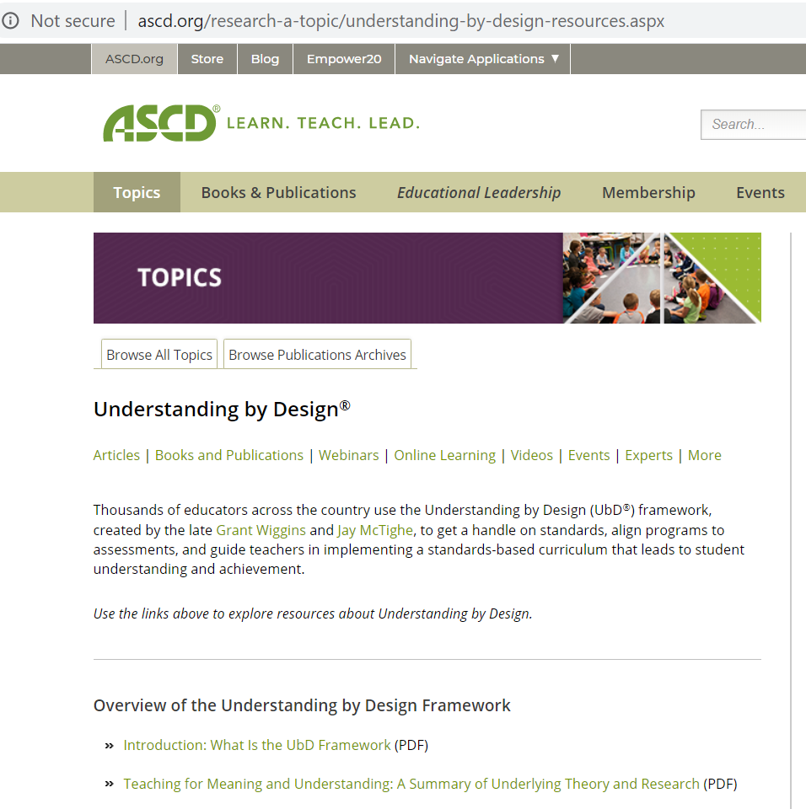

Selecting an Appropriate Learning Management System (LMS):

- The LMS used may be school managed with guest access capability or it may be open source utilizing an LMS such as Edmodo, Schoology, Canvas, or Moodle (You are not allowed to use Google Classroom). Other LMS options are permitted as approved by your professor.
- You will need to provide a 1-2 paragraph rationale on why you believe this LMS is the optimal choice. You will need to cite at least two current (within 5 years), peer-reviewed, scholarly references to support your rationale.

You must use the Mini Course: LMS Selection Template for this assignment.

For your Final Mini Course, You MUST have the Following Course Elements, and you will need to following ISTE’s Designer Educator Standards (5), located in the Mini Course: LMS Selection Resources, as you create your course:
- An Intro page with instructor and course introduction that includes 3-5 clearly stated course objectives.
- All activities align with course objectives.
- 1 Authentic Learning Activity
- 2 content videos created by you (include a text copy of your script)
- 1 video utilizing Edpuzzle
- 2 Links to other websites that support your topic.
- 1 Printable handout.
- Discussion forum
- A final 15–20-point quiz that is scorable created within your LMS.

